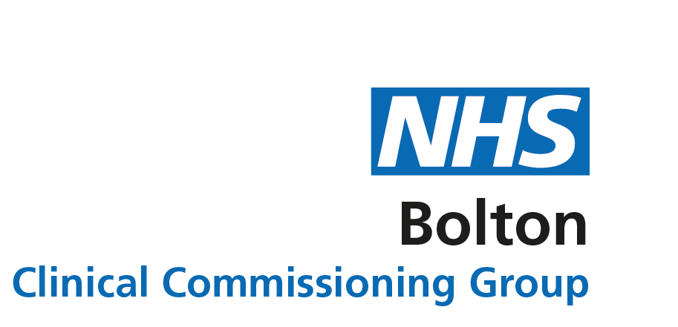
Don’t let the flu get you or your family
It’s important that you protect yourself and your family this winter.

Both Covid-19 and flu will be around at the same time and you don’t want to come down with either – or both.

The flu vaccine won’t protect you against Covid and vice versa, so if eligible you’ll need both vaccines this winter for the best protection against both viruses.

You can’t get flu from the vaccine and getting vaccinated will help to protect you and your child from becoming seriously ill.
It will also reduce the pressure on your NHS in Bolton and help to protect your community.
Some of the symptoms of Covid-19 and flu are similar, so if you have a high temperature, a new continuous cough, or you notice a change or loss in your sense of taste or smell – you must book a coronavirus PCR test.
What exactly is flu?

Influenza (flu) is a serious disease caused by a virus. It’s not just a bad cold! Sometimes, flu can develop into something worse and it kills thousands of people each year.

It spreads:

- through coughs and sneezes
- by touching things like door handles, then touching your face
- directly through saliva or nose secretions (snot!)

That’s why it’s important to wash your hands properly and ‘catch it, bin it, kill it’ using a tissue. If you don’t have a tissue handy, use the inside of your elbow!

How can I avoid getting flu?

Your best defence against flu is vaccination – you need one every year. It helps your immune system to fight off the virus, reducing your chances of getting flu and spreading it to other people.

If you do get flu, it will reduce the severity of your infection and reduce the chances of you having to go to hospital. It could save your life!

The flu vaccine is FREE for:

- those aged 50 and over
- pregnant women
- those with a long-term health condition (e.g. diabetes, COPD, kidney, heart or lung disease)*
- two and three year olds
- pupils in Reception to Year 11
- health and care workers
- carers

* check with your GP if you’re eligible.

Anyone not entitled to a free vaccine can still get protected at their local pharmacy for £10 to £15.

Please wear a face covering during your vaccination appointment.

Reception to Year 11 pupils receive a free flu nasal spray via their school health programme. Two and three year olds can have the nasal spray at their GP practice.

The nasal spray is quick and painless – no injection is needed – and it has an excellent safety record. It will help to protect not only your child against flu and serious complications such as bronchitis and pneumonia, but your loved ones and those close to you.

The children’s nasal spray can’t cause flu either. After having the nasal spray, some children might get a runny or blocked nose but this is mild in comparison to them having flu.
Having flu while pregnant can also put you and your unborn child at risk. The flu vaccine will help to protect you both.

Pregnant women are also advised to have the Covid-19 vaccine. Both the Covid-19 and flu vaccines can be taken at any stage of pregnancy.

I’ve got flu – what should I do?

- stay at home and rest until you feel better
- keep warm/drink plenty of water
- take paracetamol or ibuprofen to lower your temperature and to help with aches and pains
- you should start to feel better after a week
- antibiotics will not work against flu as it is a viral infection

Like Covid, flu is highly contagious so stay at home to avoid infecting others who may become more poorly than you. If you’re worried about symptoms, contact your GP online or by phone.

